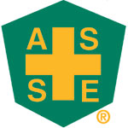Utah Chapter ASSE – Member Spotlight Form
Name | Nikkara (Nikki) Davis
Where do you work? | Cincinnati Insurance Company
How many years in Safety & Health? | 2.5 years/Previous in Claims (15 years)
Education | Business Administration - Marketing
Certification(s) | SCLA

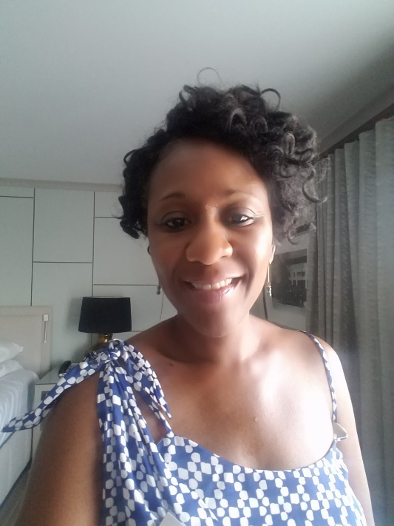
Why did you become a safety professional?
Wanted to pursue a different career path. Felt that I could make a bigger impact in safety.
What do you like most about your profession?
Diversity of business that we see on a daily basis.
What are you most proud of in your career?
The direction I am heading and the knowledge I am obtaining every day.
If you could be anything other than a safety professional what would you be?
OSHA inspector.
What do you like to do when you’re not working?
Spending time with my family, shopping and watching TV.

